UNIT TESTING Using JUnit

The JUnit framework
JUnit is a test framework which uses annotations to identify methods that specify a test. JUnit is an open source project hosted at Github.

How to define a test in JUnit?
A JUnit test is a method contained in a class which is only used for testing. This is called a Test class. To define that a certain method is a test method, annotate it with the @Testannotation.
This method executes the code under test. You use an assert method, provided by JUnit or another assert framework, to check an expected result versus the actual result. These method calls are typically called asserts or assert statements.
You should provide meaningful messages in assert statements. That makes it easier for the user to identify and fix the problem. This is especially true if someone looks at the problem, who did not write the code under test or the test code.

Example JUnit test
The following code shows a JUnit test using the JUnit 5 version. This test assumes that the MyClass class exists and has a multiply(int, int) method.
import static org.junit.jupiter.api.Assertions.assertEquals;

import org.junit.jupiter.api.Test;

public class MyTests {

@Test
public void multiplicationOfZeroIntegersShouldReturnZero() {
MyClass tester = new MyClass(); // MyClass is tested

// assert statements
assertEquals(0, tester.multiply(10, 0), "10 x 0 must be 0");
assertEquals(0, tester.multiply(0, 10), "0 x 10 must be 0");
assertEquals(0, tester.multiply(0, 0), "0 x 0 must be 0");
}
}

JUnit naming conventions
There are several potential naming conventions for JUnit tests. A widely-used solution for classes is to use the "Test" suffix at the end of test classes names.
As a general rule, a test name should explain what the test does. If that is done correctly, reading the actual implementation can be avoided.
One possible convention is to use the "should" in the test method name. For example, "ordersShouldBeCreated" or "menuShouldGetActive". This gives a hint what should happen if the test method is executed.
Another approach is to use "Given[ExplainYourInput]When[WhatIsDone]Then[ExpectedResult]" for the display name of the test method.

JUnit naming conventions for Maven
If you are using the Maven build system, you should use the "Test" suffix for test classes. The Maven build system (via its surfire plug-in) automatically includes such classes in its test scope.

Run your test from the command line
You can also run your JUnit tests outside our IDE via standard Java code. Build systems like Apache Maven or Gradle in combination with a Continuous Integration Server (like Jenkins) can be used to execute tests automatically on a regular basis.
The org.junit.runner.JUnitCore class provides the runClasses() method. This method allows you to run one or several tests classes. As a return parameter you receive an object of the type org.junit.runner.Result. This object can be used to retrieve information about the tests.
The following class demonstrates how to run the MyClassTest. This class executes your test class and write potential failures to the console.
package de.vogella.junit.first;
import org.junit.runner.JUnitCore;
import org.junit.runner.Result;
import org.junit.runner.notification.Failure;

public class MyTestRunner {
public static void main(String[] args) {
Result result = JUnitCore.runClasses(MyClassTest.class);
for (Failure failure : result.getFailures()) {
System.out.println(failure.toString());
}
}
}
This class can be executed like any other Java program on the command line. You only need to add the JUnit library JAR file to the classpath.

Test execution order
JUnit assumes that all test methods can be executed in an arbitrary order. Well-written test code should not assume any order, i.e., tests should not depend on other tests.
As of JUnit 4.11 the default is to use a deterministic, but not predictable, order for the execution of the tests.
You can use an annotation to define that the test methods are sorted by method name, in lexicographic order. To activate this feature, annotate your test class with the @FixMethodOrder(MethodSorters.NAME_ASCENDING) annotation. You can also explicitely set the default by using the MethodSorters.DEFAULT parameter in this annotation. You can also use MethodSorters.JVM which uses the JVM defaults, which may vary from run to run.

Using JUnit 4

Defining test methods
JUnit uses annotations to mark methods as test methods and to configure them. The following table gives an overview of the most important annotations in JUnit for the 4.x and 5.x versions. All these annotations can be used on methods.
Annotations in JUnit 4
JUnit 4 | Description
import org.junit.* | Import statement for using the following annotations.
@Test | Identifies a method as a test method.
@Before | Executed before each test. It is used to prepare the test environment (e.g., read input data, initialize the class).
@After | Executed after each test. It is used to cleanup the test environment (e.g., delete temporary data, restore defaults). It can also save memory by cleaning up expensive memory structures.
@BeforeClass | Executed once, before the start of all tests. It is used to perform time intensive activities, for example, to connect to a database. Methods marked with this annotation need to be defined as static to work with JUnit.
@AfterClass | Executed once, after all tests have been finished. It is used to perform clean-up activities, for example, to disconnect from a database. Methods annotated with this annotation need to be defined as static to work with JUnit.
@Ignore or @Ignore("Why disabled") | Marks that the test should be disabled. This is useful when the underlying code has been changed and the test case has not yet been adapted. Or if the execution time of this test is too long to be included. It is best practice to provide the optional description, why the test is disabled.
@Test (expected = Exception.class) | Fails if the method does not throw the named exception.
@Test(timeout=100) | Fails if the method takes longer than 100 milliseconds.

Assert statements
JUnit provides static methods to test for certain conditions via the Assert class. These assert statements typically start with assert. They allow you to specify the error message, the expected and the actual result. An assertion method compares the actual value returned by a test to the expected value. It throws an AssertionException if the comparison fails.
The following table gives an overview of these methods. Parameters in [] brackets are optional and of type String.
Methods to assert test results
Statement | Description
fail([message]) | Let the method fail. Might be used to check that a certain part of the code is not reached or to have a failing test before the test code is implemented. The message parameter is optional.
assertTrue([message,] boolean condition) | Checks that the boolean condition is true.
assertFalse([message,] boolean condition) | Checks that the boolean condition is false.
assertEquals([message,] expected, actual) | Tests that two values are the same. Note: for arrays the reference is checked not the content of the arrays.
assertEquals([message,] expected, actual, tolerance) | Test that float or double values match. The tolerance is the number of decimals which must be the same.
assertNull([message,] object) | Checks that the object is null.
assertNotNull([message,] object) | Checks that the object is not null.
assertSame([message,] expected, actual) | Checks that both variables refer to the same object.
assertNotSame([message,] expected, actual) | Checks that both variables refer to different objects.

JUnit test suites
If you have several test classes, you can combine them into a test suite. Running a test suite executes all test classes in that suite in the specified order. A test suite can also contain other test suites.
The following example code demonstrates the usage of a test suite. It contains two test classes (MyClassTest and MySecondClassTest). If you want to add another test class, you can add it to the @Suite.SuiteClasses statement.
package com.vogella.junit.first;

import org.junit.runner.RunWith;
import org.junit.runners.Suite;
import org.junit.runners.Suite.SuiteClasses;

@RunWith(Suite.class)
@SuiteClasses({
MyClassTest.class,
MySecondClassTest.class })

public class AllTests {

}

Disabling tests
The @Ignore annotation allow to statically ignore a test. Alternatively you can use Assume.assumeFalse or Assume.assumeTrue to define a condition for the test.Assume.assumeFalse marks the test as invalid, if its condition evaluates to true.Assume.assumeTrue evaluates the test as invalid if its condition evaluates to false. For example, the following disables a test on Linux:
Assume.assumeFalse(System.getProperty("os.name").contains("Linux"));

Parameterized test
JUnit allows you to use parameters in a tests class. This class can contain one test method and this method is executed with the different parameters provided.
You mark a test class as a parameterized test with the @RunWith(Parameterized.class) annotation.
Such a test class must contain a static method annotated with the @Parametersannotation. That method generates and returns a collection of arrays. Each item in this collection is used as parameter for the test method.
You can use the @Parameter annotation on public fields to get the test values injected in the test.
The following code shows an example for a parameterized test. It tests the multiply()method of the MyClass class which is included as inner class for the purpose of this example.
package testing;

import org.junit.Test;
import org.junit.runner.RunWith;
import org.junit.runners.Parameterized;
import org.junit.runners.Parameterized.Parameters;

import java.util.Arrays;
import java.util.Collection;

import static org.junit.Assert.assertEquals;
import static org.junit.runners.Parameterized.*;

@RunWith(Parameterized.class)
public class ParameterizedTestFields {

// fields used together with @Parameter must be public
@Parameter(0)
public int m1;
@Parameter(1)
public int m2;
@Parameter(2)
public int result;

// creates the test data
@Parameters
public static Collection<Object[]> data() {
Object[][] data = new Object[][] { { 1 , 2, 2 }, { 5, 3, 15 }, { 121, 4, 484 } };
return Arrays.asList(data);
}

@Test
public void testMultiplyException() {
MyClass tester = new MyClass();
assertEquals("Result", result, tester.multiply(m1, m2));
}

// class to be tested
class MyClass {
public int multiply(int i, int j) {
return i *j;
}
}

}
Alternatively to using the @Parameter annotation you can use a constructor in which you store the values for each test. The number of elements in each array provided by the method annotated with @Parameters must correspond to the number of parameters in the constructor of the class. The class is created for each parameter and the test values are passed via the constructor to the class.
package de.vogella.junit.first;
import static org.junit.Assert.assertEquals;
import java.util.Arrays;
import java.util.Collection;
import org.junit.Test;
import org.junit.runner.RunWith;
import org.junit.runners.Parameterized;
import org.junit.runners.Parameterized.Parameters;

@RunWith(Parameterized.class)
public class ParameterizedTestUsingConstructor {

private int m1;
private int m2;

public ParameterizedTestUsingConstructor(int p1, int p2) {
m1 = p1;
m2 = p2;
}
// creates the test data
@Parameters
public static Collection<Object[]> data() {
Object[][] data = new Object[][] { { 1 , 2 }, { 5, 3 }, { 121, 4 } };
return Arrays.asList(data);
}
@Test
public void testMultiplyException() {
MyClass tester = new MyClass();
assertEquals("Result", m1 * m2, tester.multiply(m1, m2));
}
// class to be tested
class MyClass {
public int multiply(int i, int j) {
return i *j;
}
}

}
If you run this test class, the test method is executed with each defined parameter. In the above example the test method is executed three times.

JUnit Rules
Via JUnit rules you can add behavior to each tests in a test class. You can annotate fields of type TestRule with the @Rule annotation. You can create objects which can be used and configured in your test methods. This adds more flexibility to your tests. You could, for example, specify which exception message you expect during the execution of your test code.
package de.vogella.junit.first;

import org.junit.Rule;
import org.junit.Test;
import org.junit.rules.ExpectedException;

public class RuleExceptionTesterExample {

@Rule
public ExpectedException exception = ExpectedException.none();

@Test
public void throwsIllegalArgumentExceptionIfIconIsNull() {
exception.expect(IllegalArgumentException.class);
exception.expectMessage("Negative value not allowed");
ClassToBeTested t = new ClassToBeTested();
t.methodToBeTest(-1);
}
}
JUnit already provides several useful rule implementations. For example, the TemporaryFolder class allows to setup files and folders which are automatically removed after each test run.
The following code shows an example for the usage of the TemporaryFolderimplementation.
package de.vogella.junit.first;

import static org.junit.Assert.assertTrue;

import java.io.File;
import java.io.IOException;

import org.junit.Rule;
import org.junit.Test;
import org.junit.rules.TemporaryFolder;

public class RuleTester {

@Rule
public TemporaryFolder folder = new TemporaryFolder();

@Test
public void testUsingTempFolder() throws IOException {
File createdFolder = folder.newFolder("newfolder");
File createdFile = folder.newFile("myfilefile.txt");
assertTrue(createdFile.exists());
}
}

Writing custom JUnit rules
To write your custom rule, you need to implement the TestRule interface. This interface defines the apply(Statement, Description) method which must return an instance of Statement. Statement represent the tests within the JUnit runtime and Statement#evaluate() run these. Description describes the individual test. It allows to read information about the test via reflection.
The following is a simple example for adding a log statement to an Android application before and after test execution.
package testing.android.vogella.com.asynctask;

import android.util.Log;

import org.junit.rules.TestRule;
import org.junit.runner.Description;
import org.junit.runners.model.Statement;

public class MyCustomRule implements TestRule {
private Statement base;
private Description description;

@Override
public Statement apply(Statement base, Description description) {
this.base = base;
this.description = description;
return new MyStatement(base);
}

public class MyStatement extends Statement {
private final Statement base;

public MyStatement(Statement base) {
this.base = base;
}

@Override
public void evaluate() throws Throwable {
System.
Log.w("MyCustomRule",description.getMethodName() + "Started" );
try {
base.evaluate();
} finally {
Log.w("MyCustomRule",description.getMethodName() + "Finished");
}
}
}
}
To use this rule, simple add a field annotated with @Rule to your test class.
@Rule
public MyCustomRule myRule = new MyCustomRule();

Categories
It is possible to define categories of tests and include or exclude them based on annotations. The following example is based on the JUnit 4.8 release notes.
public interface FastTests { /* category marker */
}

public interface SlowTests { /* category marker */
}
public class A {
@Test
public void a() {
fail();
}
@Category(SlowTests.class)
@Test
public void b() {
}
}
@Category({ SlowTests.class, FastTests.class })
public class B {
@Test
public void c() {
}
}

@RunWith(Categories.class)
@IncludeCategory(SlowTests.class)
@SuiteClasses({ A.class, B.class })
// Note that Categories is a kind of Suite
public class SlowTestSuite {
// Will run A.b and B.c, but not A.a
}

@RunWith(Categories.class)
@IncludeCategory(SlowTests.class)
@ExcludeCategory(FastTests.class)
@SuiteClasses({ A.class, B.class })
// Note that Categories is a kind of Suite
public class SlowTestSuite {
// Will run A.b, but not A.a or B.c
}

Eclipse support for JUnit 4

Creating JUnit tests
You can write the JUnit tests manually, but Eclipse supports the creation of JUnit tests via wizards.
Example, to create a JUnit test or a test class for an existing class. Right-click on your new class, select this class in the Package Explorer_ view, right-click on it and select New ▸ JUnit Test Case.
Alternatively you can also use the JUnit wizards available under File ▸ New ▸ Other…​ ▸ Java ▸ JUnit.

Running JUnit tests
The Eclipse IDE also provides support for executing your tests interactively.
To run a test, select the test class, right-click on it and select Run-as ▸ JUnit Test.
This starts JUnit and executes all test methods in this class.
Eclipse provides the Alt+Shift+X, T shortcut to run the test in the selected class.
To run only the selected test, position the cursor on the test method name and use the shortcut.
To see the result of a JUnit test, Eclipse uses the JUnit view which shows the results of the tests. You can also select individual unit tests in this view, right-click on them and select Run to execute them again.
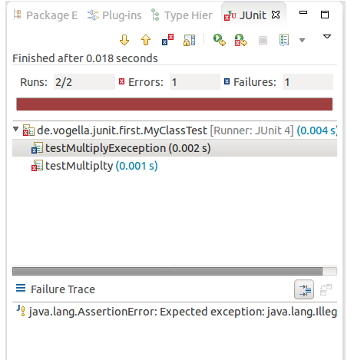
By default, this view shows all tests. You can also configure, that it only shows failing test
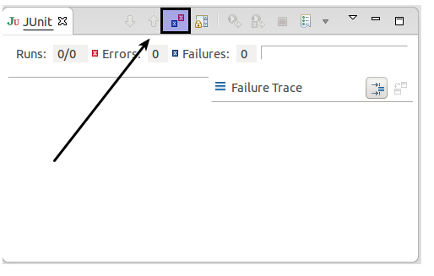
You can also define that the view is only activated if you have a failing test.
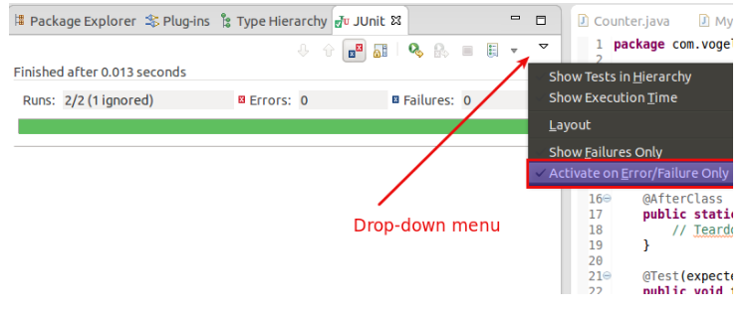
NOTE: Eclipse creates run configurations for tests. You can see and modify these via the Run ▸ Run Configurations…​ menu.

Extracting the failed test and stacktraces
To get the list of failed test, right click on the test result and select Copy Failure List. This copies the failed tests and there stack traces into the clipboard.
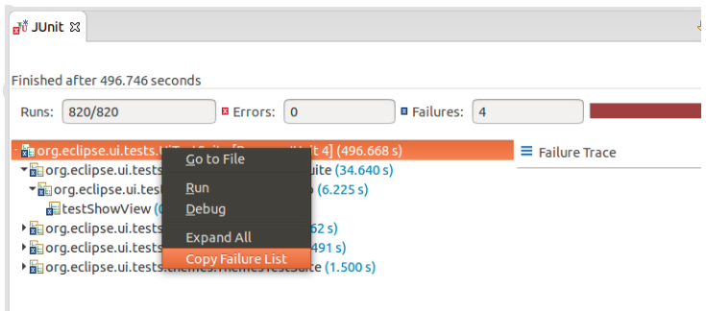
JUnit static imports
Static import is a feature that allows fields and methods defined in a class as public static to be used without specifying the class in which the field is defined.
JUnit assert statements are typically defined as public static to allow the developer to write short test statements. The following snippet demonstrates an assert statement with and without static imports.
// without static imports you have to write the following statement
Assert.assertEquals("10 x 5 must be 50", 50, tester.multiply(10, 5));
// alternatively define assertEquals as static import
import static org.junit.Assert.assertEquals;
// more code
// use assertEquals directly because of the static import
assertEquals("10 x 5 must be 50", 50, tester.multiply(10, 5));

Wizard for creating test suites
You can create a test suite via Eclipse. For this, select the test classes which should be included in suite in the Package Explorer view, right-click on them and select New ▸ Other…​ ▸ JUnit ▸ JUnit Test Suite.
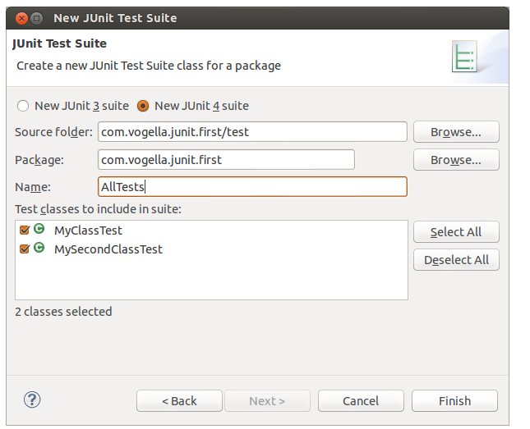

Testing exception
The @Test (expected = Exception.class) annotation is limited as it can only test for one exception. To testexceptions, you can use the following testpattern.
try {
mustThrowException();
fail();
} catch (Exception e) {
// expected
// could also check for message of exception, etc.
}

5.7. JUnit Plug-in Test
JUnit Plug-in tests are used to write unit tests for your plug-ins. These tests are executed by a special test runner that launches another Eclipse instance in a separate VM. The test methods are executed within that instance.

Exercise: Using JUnit

Project preparation
Create a new project called com.vogella.junit.first. Create a new source folder test. For this right-click on your project, select Properties and choose Java ▸ Build Path. Select the Source tab.
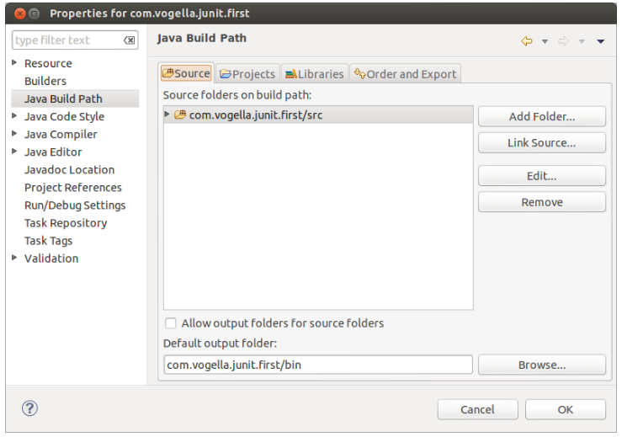
Press the Add Folder button. Afterwards, press the Create New Folder button. Enter test as folder name.
The result is depicted in the following screenshot.
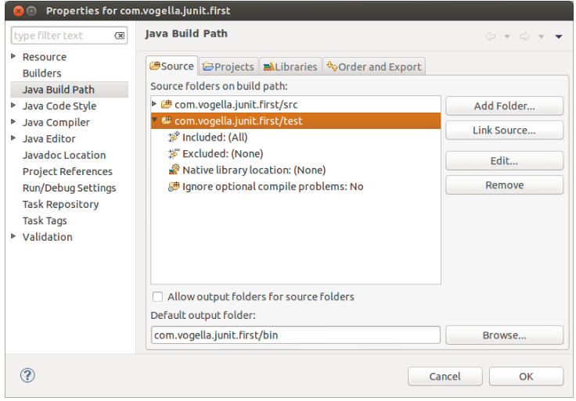
You can also add a new source folder by right-clicking on a project and select New ▸ Source Folder.

Create a Java class
In the src folder, create the com.vogella.junit.first package and the following class.
package com.vogella.junit.first;

public class MyClass {
public int multiply(int x, int y) {
// the following is just an example
if (x > 999) {
throw new IllegalArgumentException("X should be less than 1000");
}
return x / y;
}
}

Create a JUnit test
Right-click on your new class in the Package Explorer view and select New ▸ JUnit Test Case.
In the following wizard ensure that the New JUnit 4 test flag is selected and set the source folder to test, so that your test class gets created in this folder.
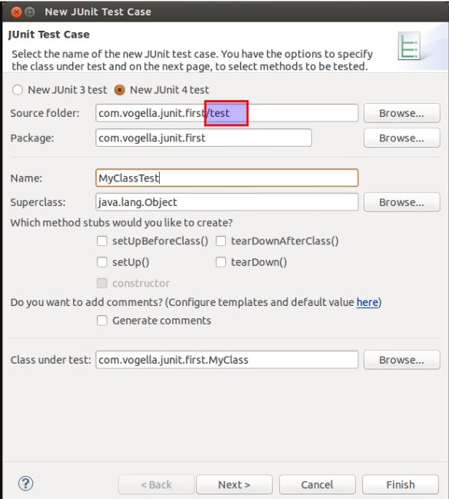
Press the Next button and select the methods that you want to test.
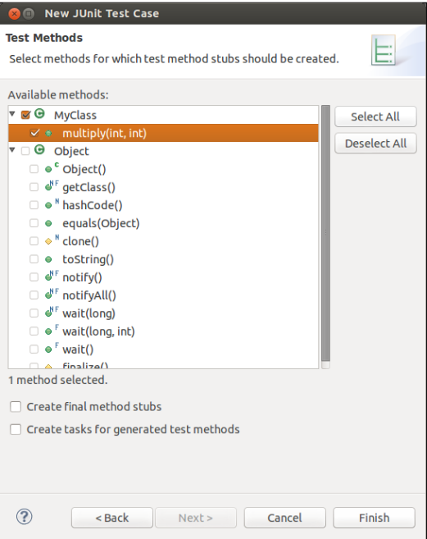
If the JUnit library is not part of the classpath of your project, Eclipse will prompt you to add it. Use this to add JUnit to your project.
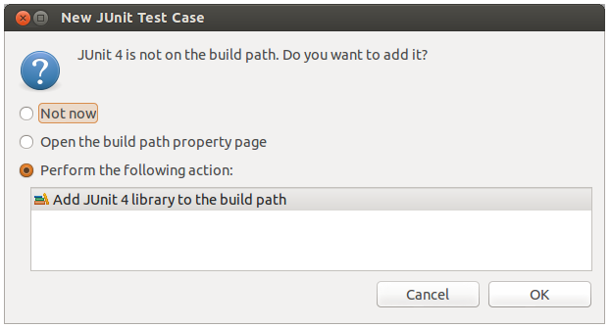
Create a test with the following code.
package com.vogella.junit.first;

import static org.junit.Assert.assertEquals;

import org.junit.AfterClass;
import org.junit.BeforeClass;
import org.junit.Test;

public class MyClassTest {

@Test(expected = IllegalArgumentException.class)
public void testExceptionIsThrown() {
MyClass tester = new MyClass();
tester.multiply(1000, 5);
}

@Test
public void testMultiply() {
MyClass tester = new MyClass();
assertEquals("10 x 5 must be 50", 50, tester.multiply(10, 5));
}
}

Run your test in Eclipse
Right-click on your new test class and select Run-As ▸ JUnit Test.
The result of the tests are displayed in the JUnit view. In our example one test should be successful and one test should show an error. This error is indicated by a red bar.
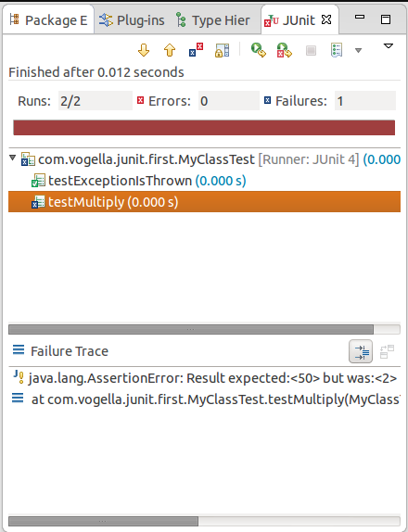
The test is failing, because our multiplier class is currently not working correctly. It does a division instead of multiplication. Fix the bug and re-run the test to get a green bar.

